Talk Circles: Introducing Oracy
Facilitator Notes

Materials: PowerPoint presentation, facilitator notes, session handouts, video clip commentaries, post-it notes (optional).

Slide | Facilitator notes
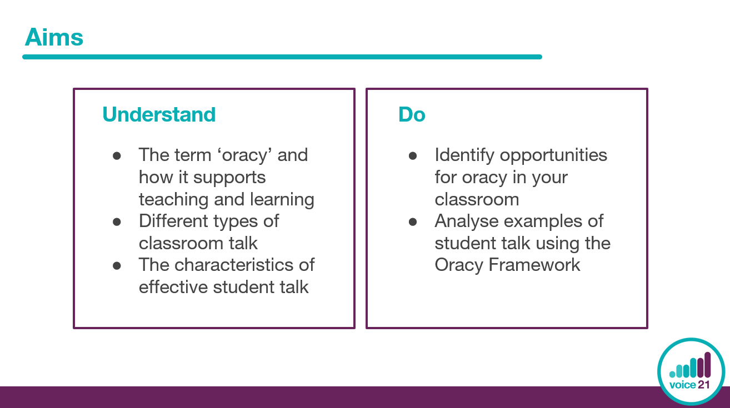 | Time: 1 minute  - Introduce Talk Circles and unpick aims of the session.
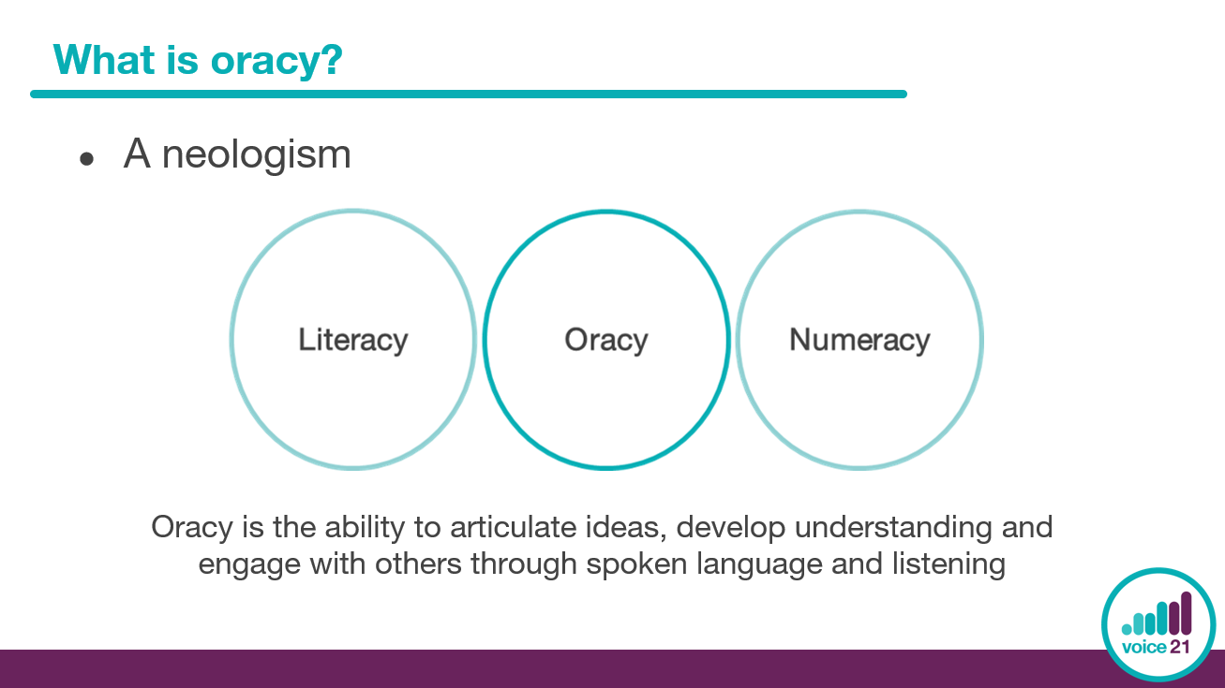 | Time: 3 minutes  - Explain that oracy is a ‘neologism’ – a newly coined word or expression – which was first devised by Andrew Wilkinson in the 1960s in direct response to the growing importance placed on literacy and numeracy. It captures the essential need for talk (just as one needs to be literate and numerate) and also emphasises that it is a skill which can be acquired through teaching.  - Introduce Voice 21’s definition of oracy, highlighting emphasis on listening and communication, as well as speaking.

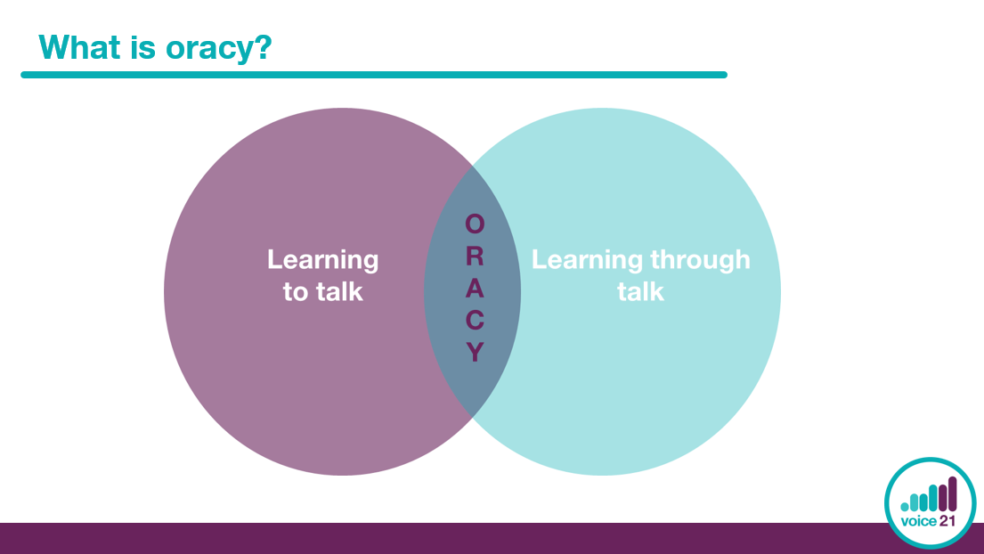 | Time: 2 minutes  - Explain that in a classroom context, oracy is both learning to and through talk, as captured in this Venn diagram.  - It is through talk that students use their collective thinking power to build and revise their understanding, negotiate complex ideas and problem solve.  - However, to engage productively in talk for learning, students must also learn the skills they need to talk effectively.  - Through oracy education, students learn both to and through talk.
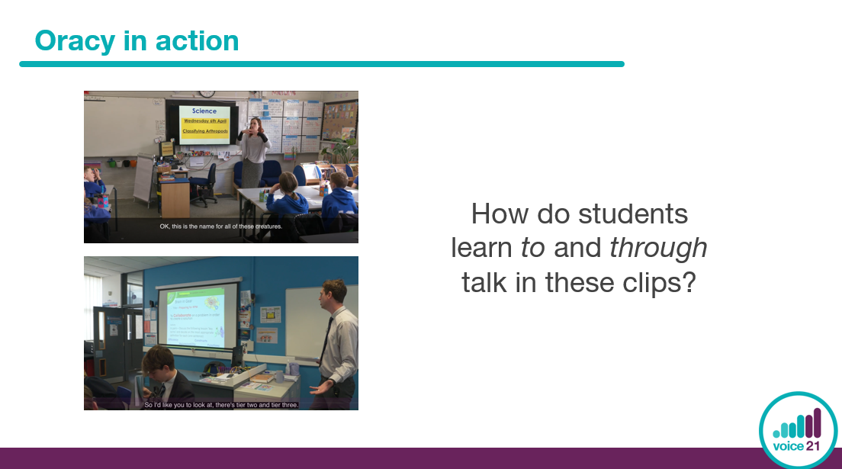 | Time: 8 minutes  - Introduce the clip of oracy in action.  - Ask colleagues to make a note on their session handout of how students are learning to and through talk in this clip.  - Play the clip.  Note: choose the most appropriate video clip for your setting. We have included a primary and secondary clip.
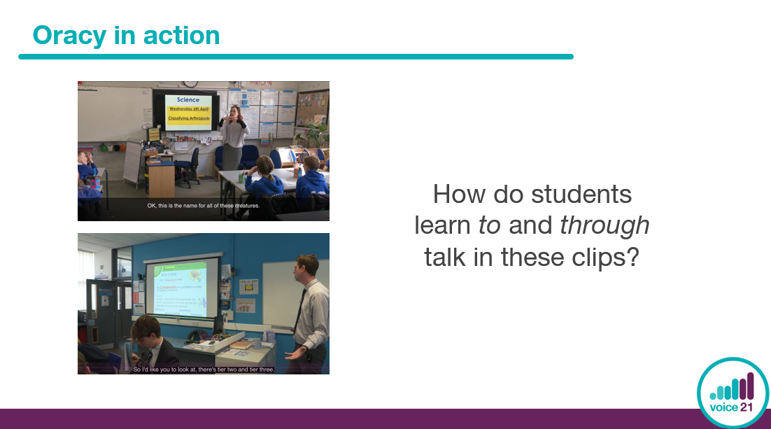 | Time: 8 minutes  - In pairs, ask colleagues to share what they noticed about how students in the clip learnt to and through talk.  - Choose a few colleagues to summarise their discussions for the group and use the video clip commentary to facilitate a wider-group discussion.  - You could ask:  - What were the teachers’ expectations for oracy and how did she share these with her students?  - What oracy skills do you think these students have been taught?  - What routines for talk have been established in this classroom?  - How did the opportunities for talk in this clip support students’ learning?
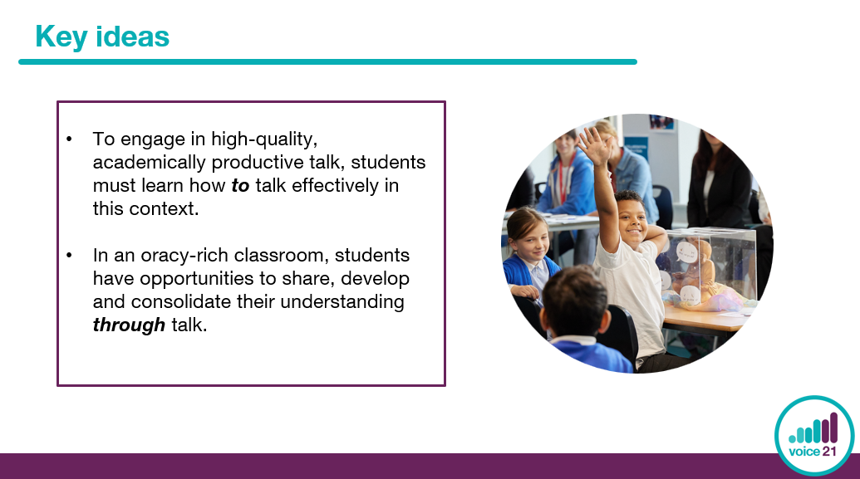 | Time: 1 minute  - Recap the key ideas from this section.
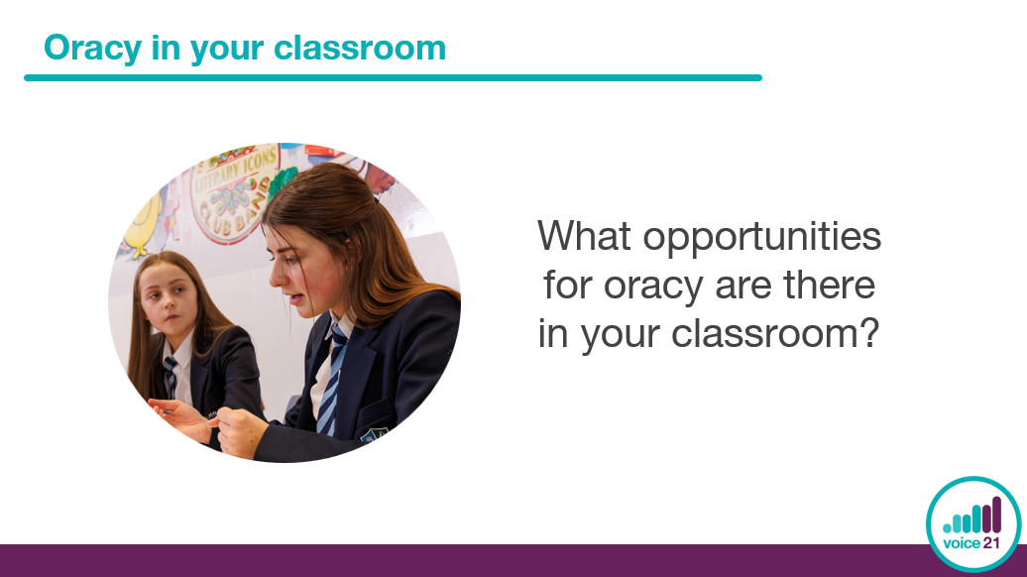 | Time: 2 minutes  - Explain to colleagues that we are now going to think about oracy in their classrooms.  - Ask them to think of as many different opportunities for oracy that there are in their classrooms, recording one per post-it note. For example, hot seating, debate, think-pair-share.
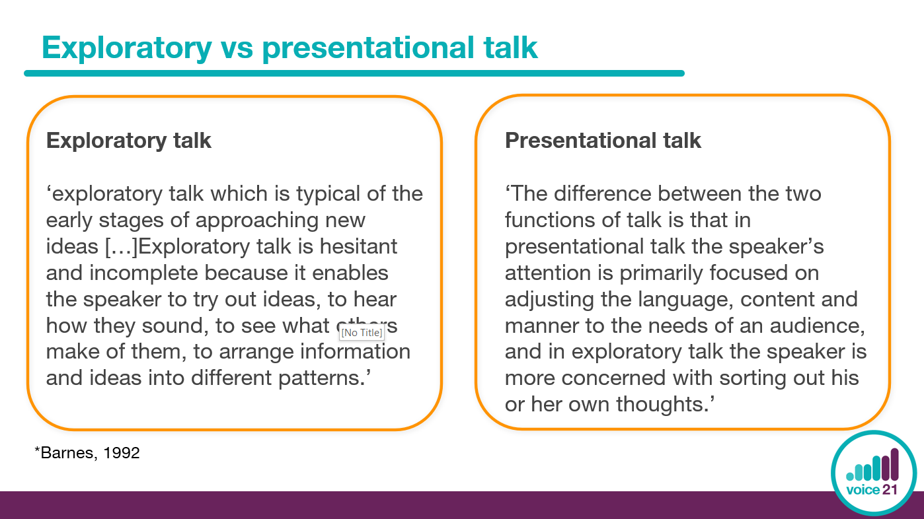 | Time: 3 minutes  - To help conceptualise and understand the differences between the types of talk that most commonly happen in the classroom, Douglas Barnes has made the distinction between ‘exploratory’ and ‘presentational’ types of talk.  - Exploratory talk is how we develop and explore ideas together, whereas presentational talk involves “presenting” our understanding to others.  Note: A common misconception is that presentational talk is always “preprepared”. In fact, presentational talk can be spontaneous. The key difference between exploratory and presentational talk is that “in presentational talk the speaker’s attention is primarily focused on adjusting the language, content and manner to the needs of an audience, and in exploratory talk the speaker is more concerned with sorting out his or her own thoughts” (Barnes, 2008)
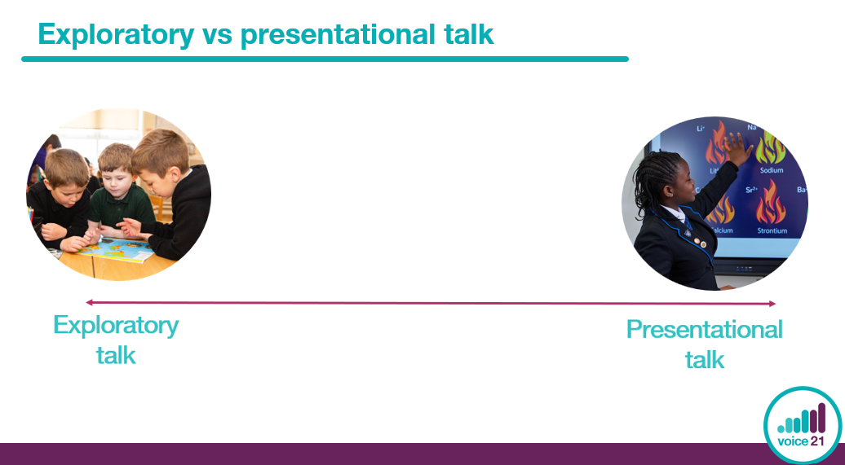 | Time: 6 minutes  - Share the ‘talk continuum’ with colleagues (copy included in session handouts).  - In small groups, ask them to arrange the opportunities for oracy in their classrooms (which they recorded on post-it notes earlier) onto the continuum, placing them near exploratory or presentational talk, or somewhere in the middle.  - Ask colleagues to justify and explain where they placed different opportunities for talk on the continuum.  - Explain that the hallmarks of good oracy change depending on the context in which we are speaking. So, in the classroom, our expectations for oracy will differ depending on whether we are asking students to engage in exploratory or presentational talk.  Note: some opportunities for talk, such as ‘answering a teacher’s question’ or ‘role play’ could be exploratory or presentational depending on whether the focus is students developing their own understanding or sharing this with others.
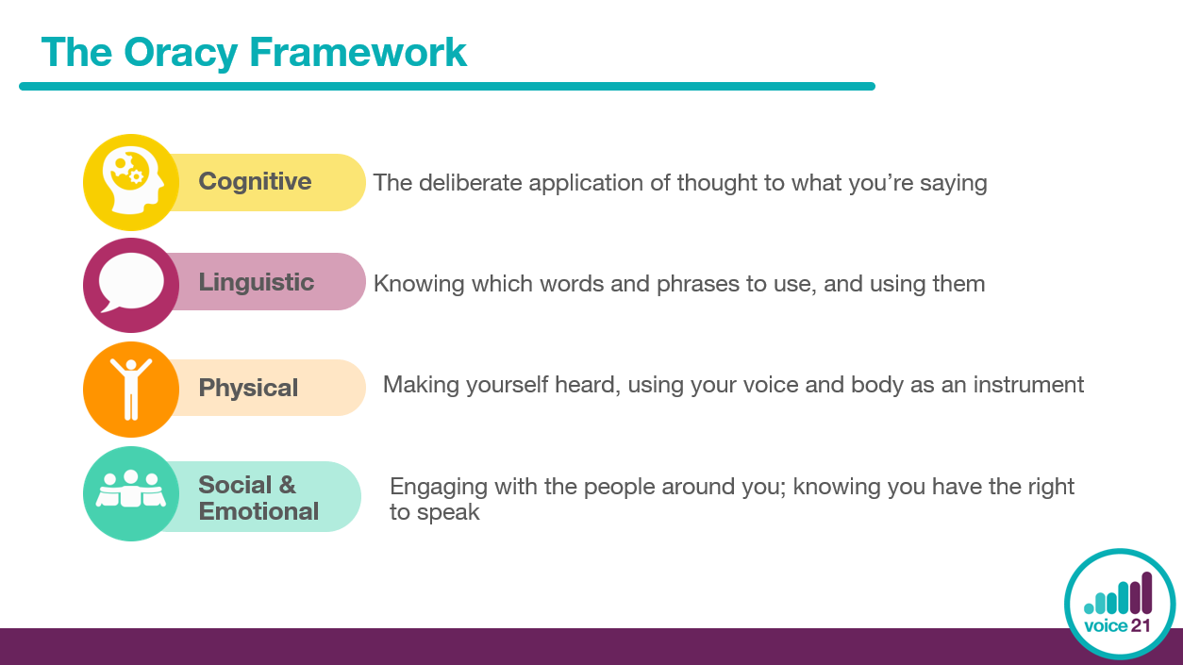 | Time: 3 minutes  - The Oracy Framework, devised by Voice 21 and Oracy Cambridge, provides a framework through which we can understand what constitutes good speaking, listening and communication in different contexts.  - It breaks down the skills within oracy into four distinct but interlinked strands: physical, linguistic, cognitive and social emotional.
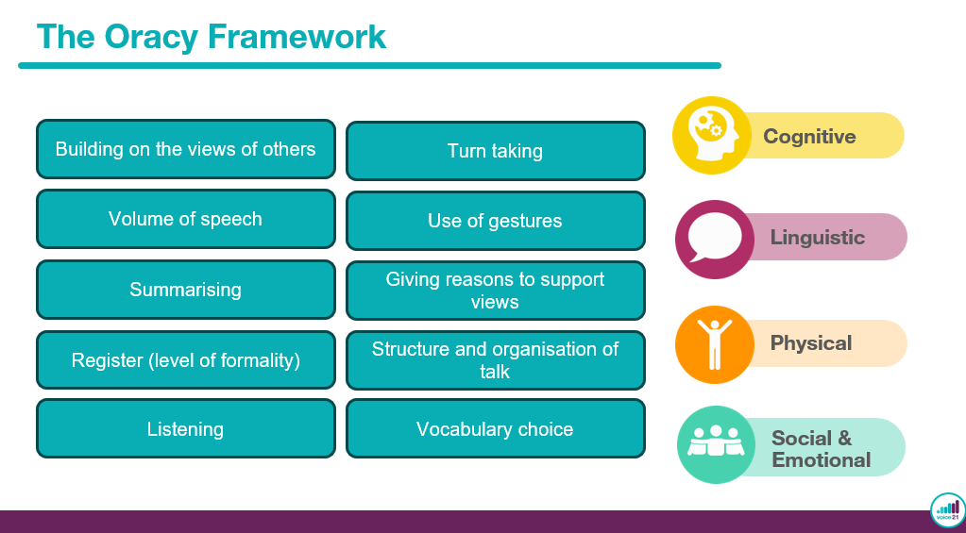 | Time: 3 minutes  - Ask colleagues to work together in small groups to decide which skill listed on the left belongs to which strand of the Oracy Framework.  Note: it could be argued that some skills sit in multiple strands. For example, choosing the correct register involves knowing your audience (social & emotional), selecting the right content (cognitive) and using appropriate tone and body language (physical). However, it is nested under the linguistic strand because it relates primarily to the language choices a speaker makes. Encourage your colleagues to choose the best-fit strand for each skill.
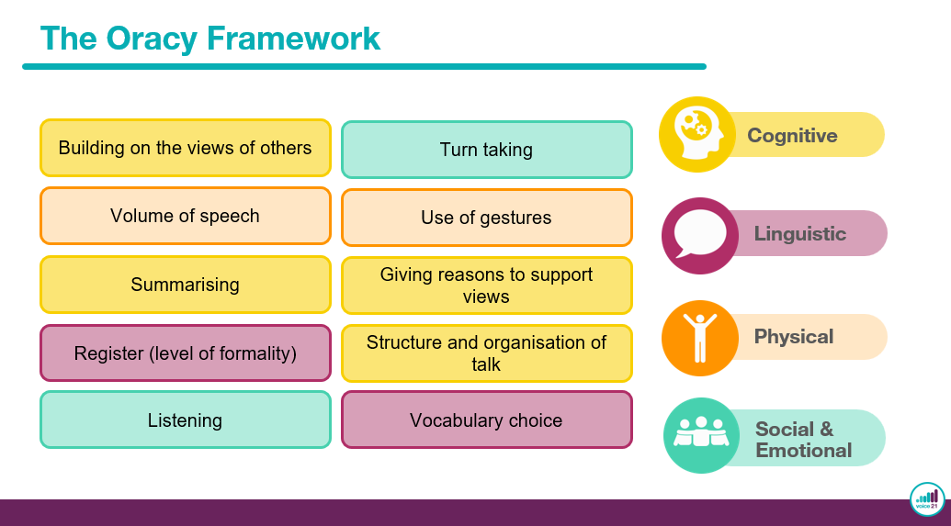 | Time: 1 minute  - After a few minutes, bring the group back together and share the answers with your colleagues:  - You could ask:  - Were there any surprises?  - Any skills that sparked debate?  - Are there any skills which they might have categorised differently?
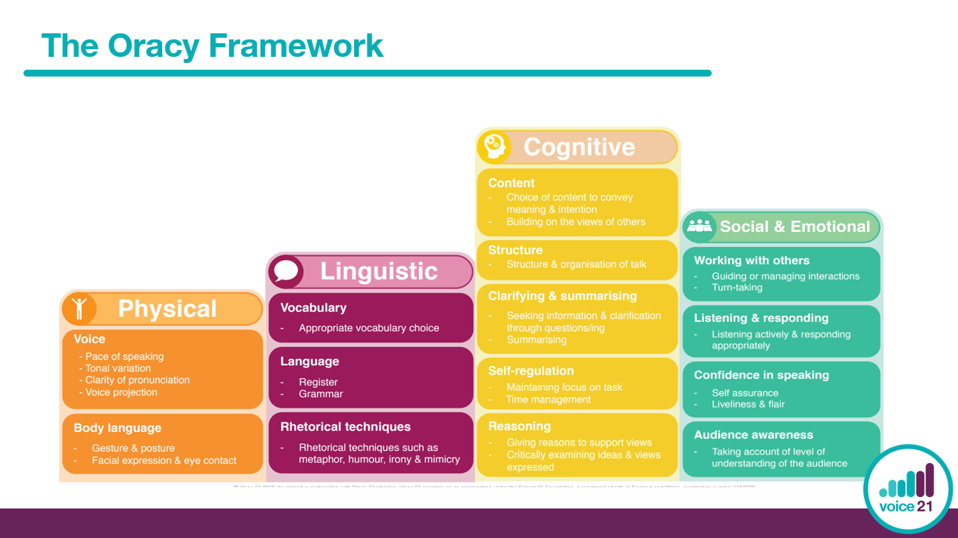 | Time: 3 minutes  - Share the expanded version of the Oracy Framework.  - Ask colleagues to consider the subset of skills in each strand.  - You could ask:  - Which strands or skills are particularly important in their subject or phase?  - Which strands are their students’ strongest?  - Which strands might they need to work on?
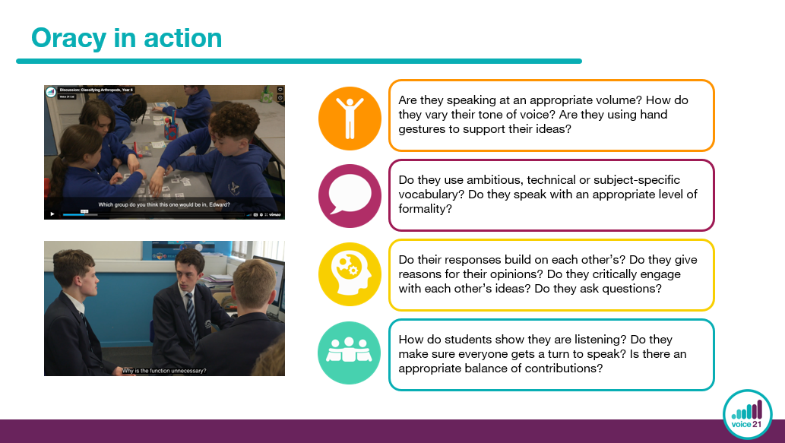 | Time: 4 minutes  - Choose the video which corresponds to the lesson clip you watched earlier.  - Explain to colleagues that they are going to become ‘Talk Detectives’. Using the prompt sheet on their session handout, ask colleagues to watch the video clip and make notes against each of the four strands of the Oracy Framework on their session handout.  Note: the secondary video clip is the same one you watched earlier. For this section, just rewatch the discussion which begins at 3:19 and finishes at 4:57. The primary clip features one extended discussion. You don’t need to watch the whole discussion and could choose to stop after a few minutes.
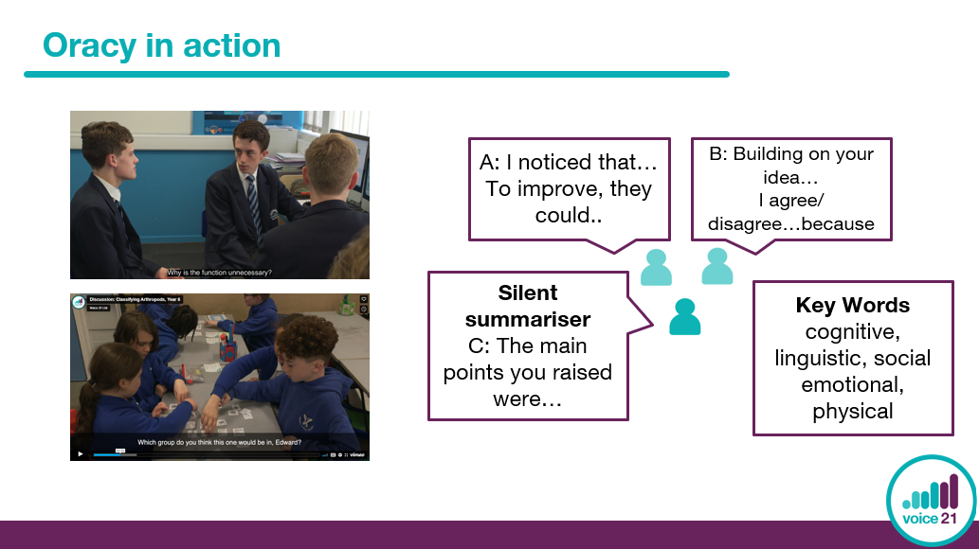 | Time: 8 minutes  - Ask colleagues to organise themselves into trios, assigning themselves the role ‘A’, ‘B’ or ‘C’.  - Ask ‘A’ and ‘B’ to use the prompts on the board to share their reflections on the video clip, focusing on how the students applied the four strands of the Oracy Framework. While ‘A’ and ‘B’ discuss, ask person ‘C’ to stay silent, listening into their conversation. When their discussion draws to a close, ‘C’ then summarises the discussion (modelled approach: silent summariser).  - Bring the group back together and ask a few ‘silent summarisers’ to share their reflections on the video clips. Use the video clip commentary notes to facilitate a wider discussion.
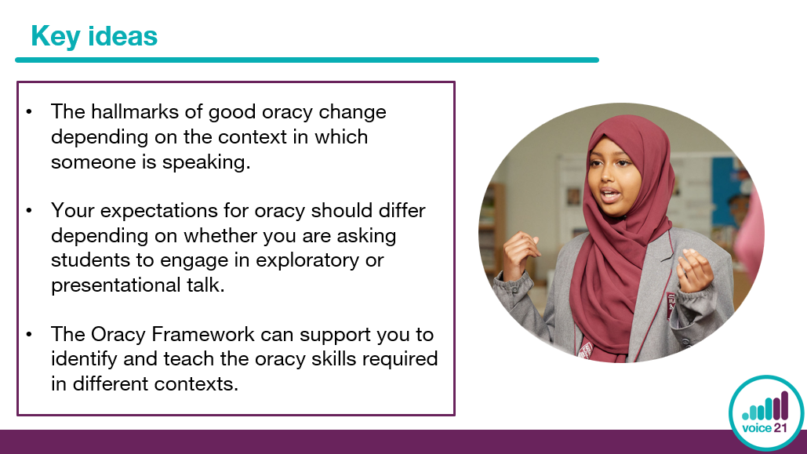 | Time: 1 minute  - Recap the key ideas from this section.
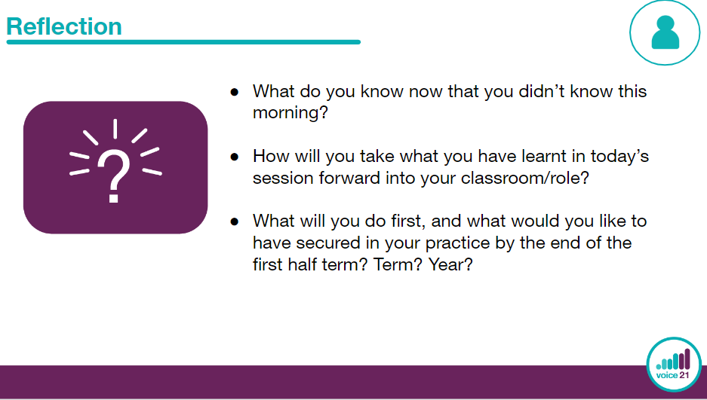 | Time: 3 minutes  - Provide participants with some time to reflect on the ‘Talk Circle’ session in relation to their own understanding and setting.  - Share reflections and use to inform agreed next steps (see next slide)  - Spend time discussing what participants will do next and create purposeful, tangible next steps as a school (phase/ department/team) using these suggested next steps as a guide.  Note: we have suggested next steps as a guide. Please adapt these to suit your school’s context and priorities.
